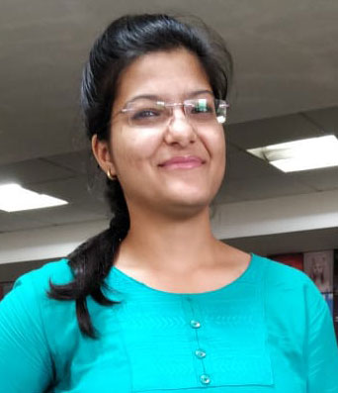

**Mail**

**Tradeboox Tech India Pvt Ltd**

Role: Software Developer

**Responsibilities:**

* Utilizing Python and Django to design server applications and client interfaces.
* Development and Testing
* Good integration and testing of the application
* Handling development and management of front end user interfaces with help of HTML, CSS and JavaScript.

**Project(Invoice):**

* Back end – Python, django
* Team of employee – 3

English

Hindi

**Language Known**

Your adress tunisie azertyazert azerty  
hhhhhhhhh

http://www.linkedin.com/in/anamikajain8602/

**LinkedIn**

66A, NEAR CANERA BANK, MUNIRKA, SOUTH DELHI, 110067. Mob. No. : +919871276993

anamikaj8602@gmail.com

+919871276993

**Address**

**Mobile**

**­­Bachelor of Eng. (Electrical and Electronics)**

Rajiv Gandhi Proudyogiki Vishwavidyalaya

**HSE**

M.P. BOARD

**SSE**

U.P. BOARD

**Hobbies**

* Cooking
* Reading novels
* Writing poems

2017-Till Now

**SKILLS**

**EDUCATION**

2013-2017

**EXPERIENCE**

**Software Developer**

**ANAMIKA JAIN**

2012-2013

2011-2012

Phyton

django

HTML

CSS

POSTGIESQL

Bootstrap

**OBJECTIVE**

**CONTACT**

**SOCIAL MEDIA**

To work with an organization where I can nourish my skills which could enable my professional growth while fulfilling organizational goals and use my strengths and capabilities to their fullest and in a productive manner. Importantly, to establish my own identity in life.