Cirriculum Vitae
Sunny Rajendra Pandya
Email: sunny.r.pandya@gmail.com
Ph no: 8306285041

Current Profile: Front end and middleware developer with Python Django and javascript, HTML, jquery at Vavni Inc. I have also worked as in automation testing frameworks. Apart from my technical skills, i also possess good interpersonal and marketing skills.

Technical knowhow: Below table shows the tools and technologies that I have worked on or learnt.
Type | Tools and Technology
Programming Language | Python, C, Java(core)
Scripting Language | Shell, Javascript, Jquery
Operating Systems | Linux(Ubuntu), Windows
Tools | Eclipse(pyDev)
Other Technologies | Django, Twitter bootstrap, CSS3, HTML, HTML5

Work Experience(Newest First):

Company: Vavni Services Pvt Ltd
Client: Seagate Inc.
Project Name: Seagate SpyGlass/ LaCie Fuel
Duration: 12 months
Description: Seagate SpyGlass is another product to Seagate’s wireless HDD family. You can check the below projects to know the hierarchy of wireless projects. It is a low cost version of Seagate Wireless Plus with a completely new and enriched user Interface. It is low cost projects in terms of its hardware capacity and wifi capacity. It also serves with all the standard features that Wireless Plus had like Samba Share, WebDav and MiniDLNA. It is also complaint with the standards of Samba and MiniDLNA.

Role: My area of work in this project was more on the front end as this project had most of its architecture reused that of Seagate Wireless Plus which acts as parent project to this one. I have worked on Javascript, HTML, AJAX, Jquery, CSS and Django for the same. The project had two User Interfaces based on screen size segment in mobile devices. I had worked on the Large Screen device User Interface development.

Company: Vavni Services Pvt Ltd
Client: Seagate Inc.
Project Name: Seagate Wireless Plus
Duration: 12 months
Description: With Seagate® Wireless Plus, you can enjoy your media and access your files without wires or the Internet. This mobile storage device broadcasts its own WiFi network, so you can wirelessly stream your media and files to your tablet or smart phone on-the-go and off-the-grid. The free Seagate Media app for iOS and Android® makes it easy to navigate and enjoy content wherever you go. Forget about having to choose which files to load onto your tablet or smartphone before a trip. Bring it all with you! Wireless Plus has 1TB of built-in storage, which means you can load up to 500 movies or thousands of songs, photos and documents. Simply drag-and-drop to load files wirelessly from your PC or Mac® computer or use the USB 3.0 adapter to load files up to 10× faster than Wi-Fi N. Wireless Plus allows up to eight tablets and smart phones to access and store content at the same time. Leave it in your bag, set it on the table, place it anywhere in the car with a range of up to 150ft you’ll never feel tethered to your storage. Best of all, by creating its own Wi-Fi network, there is no need for an Internet connection and you don’t have to use your data plan.

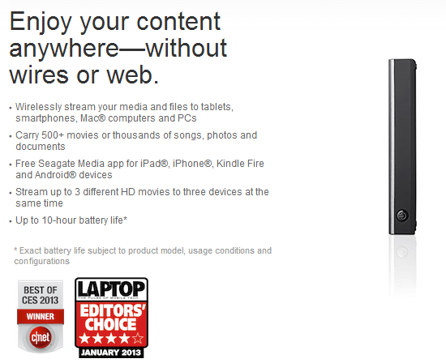

Role: I have worked on another project from Seagate called Seagate GoFlex Phoenix(Wireless Plus) that is the higher version of the Seagate GoFlex Satellite with some added features like Samba share, webDav, MiniDLNA compliance and many others. It was an experience of around 13 months as a developer. In this project, I have worked on the front end and middleware side. This experience was based on developing web APIs for the project that was made in python django framework. We had also developed two kinds of User interfaces. One UI for large screens and other for small screen devices. The user interface provided both cross browser and cross platform support. The technologies involved were Python, Django, javascript, CSS, HTML &Jquery. My work in this project started right from the discussion phase to the final release. In this project i have also worked on implementation of telemetry i.e. dynamic upload of user data using REST to a server for analysis. This was a project in itself which was made in python.

Company: Vavni Services Pvt Ltd
Client: Seagate Inc.
Project Name: Seagate GoFlex Satellite
Duration: 3 months
Description: Carry your media library with you while on-the-go and wirelessly stream media to your iPad® or Android® tablet. GoFlex Satellite™ mobile wireless storage allows you to carry your media library with you while on-the-go and wirelessly stream movies, photos, music and documents to your iPad®, Android tablet or smartphone. The GoFlex Satellite device includes a fast USB 3.0/USB 2.0 connection and downloadable Media Sync software to easily transfer media and documents from your PC or Mac® computer. The GoFlex Satellite device can store over 300 HD movies*, so you’ll never have to worry about running out of space on your tablet or smartphone. After you load your media on to the GoFlex Satellite device, it can be streamed to your tablet or smartphone via its Wi-Fi connection, making the solution completely wireless. Leave it in your bag, set it on the table, place it anywhere in the car – with a range of up to 150ft you’ll never feel tethered to your storage. Best of all, the GoFlex Satellite device creates its own Wi-Fi network, so there’s no Internet required – take it all with you and
access it wherever, whenever. To enhance your experience even further, download the free GoFlex Media™ app for iPad®, iPhone®, iPod® touch, Android tablets and smartphones from the Apple® App store or the Android Market. The GoFlex Media app is tailored for the GoFlex Satellite device allowing you to easily sort through your media library by Videos, Photos, or Music, keyword search, and folder and thumbnail views. The app also allows you to download movies and other media from the GoFlex Satellite device, so that you can enjoy your content later, when not connected or extend the battery life of both your mobile device and GoFlex Satellite. If you love media, it’s only fair to share. The GoFlex Satellite device can stream movies and other media to almost any device that has a web browser and Wi-Fi connectivity. If your friends and family have a smartphone, tablet or laptop, they can enjoy your media content too. In fact, the GoFlex Satellite device can stream 3 different movies to 3 devices simultaneously, so everyone in the family can enjoy their favorite content. Additionally, the built-in battery enables the GoFlex Satellite device to standby, ready to serve media for up to
25 hours and can continuously stream up to 5 hours of video on a single charge.
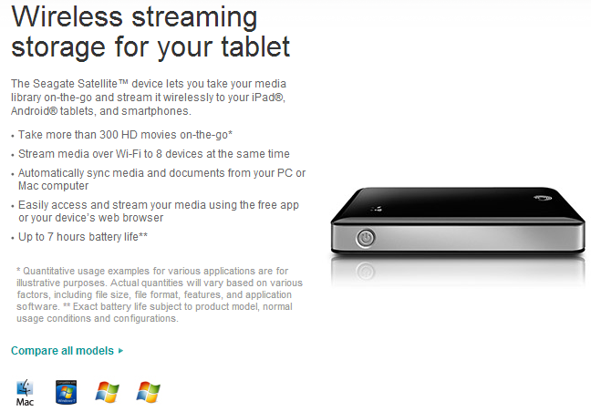
Role: Another phase and designation was as a developer in the same project(Seagate GoFlex Satellite). I had worked on python for product API development. I had also worked on the frontend part of the project as a developer for five months. The technical experience included Python (Django framework), javascript, jquery, XML, JSON, AJAX, HTML and CSS.

EDUCATION

Major: Diploma Executive in Marketing
Institute of Management, Nirma University
Result: Awaiting
Year of passing: 2014

Major: Bacherlors in Computer Engineering(Class- First).
Gandhinagar Institute Of Technology, Gandhinagar.
University: Gujarat University
Percentage: 63.2%
Year of passing: 2011

Class 12th(Science-Engg)
Baroda High School, Alkapuri, Baroda.
Board: GSHSEB
Percentage: 70%
Year of passing: 2007

Class 10th
SabariVidyalaya, Baroda
Board: GSHSEB
Percentage: 86.6%
Year of passing: 2005

ACTIVITIES

- Captained college class cricket team for two years.
- Class Representative of class for four years during bachelors.
- Lead Vocalist of a rock band during bachelors.
- Excellent academics in school and good communication skills.

