georgeconnect.com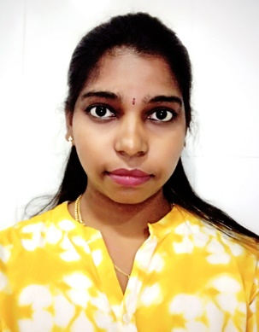sss



STC Technologies

Certified Software Testing Professional, Manual testing and Auotmation testing

Quick Test Professional (QTP), HP Quality Centre, Selenium

**Certification**

Participated in Aurgnate Technical Symposium and got First prize for the paper presentation.

Python/R

PHP/CodeIgniter

AngularJS

SQL/Postgres/MongoDB

**Skills**

9840379517

[vinodhini.b1992@gmail.com](mailto:vinodhini.b1992@gmail.com)

No.9 Kaveri Street, Sri Ranga Nagar, Moulivakkam, Porur, Chennai – 600116.

**Contact**

Rewarded Star of the Month for Sept month as a Junior Programmer in TertiumQuidPvt Ltd 2015

Received NTT DATA Best Performance Badge 2017

Participated in Artificial Intelligence NTTDATA GLOBAL Hackathon at Munich, Germany 2018

**Awards**

**July 2014 – Dec 2014 | Assistant Programmer**

Electronic Corporation of TN Limited.

Online Reply System (Chief Minister Special Cell in Secretariat)

web application for customer feedback in the form of survey

Tertiumquid Information Services Pvt. Ltd.

**July 2015 – Jan 2016 | Junior Programmer**

Worked in Customer Relation Management SugarCRM.

Vinformax Technology System.

**Apr 2016 – July 2016 | Programmer**

Software Application Development, worked in Online Civil Monitoring System & Online Procurement System

Electronic Corporation of TN Limited.

**Aug 2016 – May 2017 | Programmer**

Research and Development, worked in D’REAP Project (NLP) & HEURI Project (Predictive Analytics)

NTTDATA, Chennai

**Present | Data Scientist**

**Work Experience**

April 2009HSC, TN State board,

Jai Gopal Garodia Govt Girls Hr. Sec. School.

April 2007

SSLC, TN State board,

Jai Gopal Garodia Govt Girls Hr. Sec. School.

May 2013B.E – Biomedical Engineering,Rajiv Gandhi College of Engineering.

**Education**

Intend to build a career with leading corporate of hi-tech environment with committed & dedicated people, which will help me to explore myself fully and realize my potential. I have 1+ years’ experience in Data Scientist & 2+ years’ experience in software development.

**About Me**

**Data Scientist Expert**

Vinodhini Baskar.