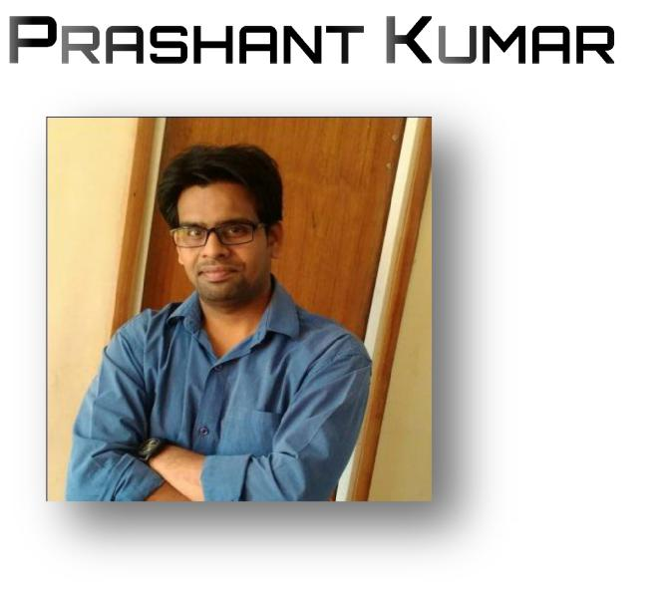
• M O DI NAG AR
• P R A S H A N T .J Y A N T H @G M A I L .C O M

• +91-9258424327,
• +91-8810591519

SKILLS AND PROFICIENCY

Python Developer, EMBEDDED C DEVELOPER , CORPORATE TRAINER, Software Developer

IDE: Python IDLE, Jupyter NoteBook, AWS Cloud9, Azure(ML), AVR Studio, KEIL and Proteus, Microsoft Visual Studio(C/C++), Processing, Arduino etc.

Microcontrollers: 8051, AVR(Atmega328)

Additional tools and Technologies: Machine Learning, NLP, Sentiment Analysis, Tweeter API, GUI, Data Analysis, PCB designing and simulation, Circuit debugging, OpenCV (Computer Vision), Numpy, Matplot,Pandas, Minim(Audio tools), SimpleOpenNI, TUIO, Kinect SDK, Oscilloscope, Proteus, AVR Studio, Bluetooth, ESP8266 etc

- EVELOPMENT

- QR Code Reading Software
- Google API GPS(GOOGLE EARTH)
- GUI Development Python(Tkinter)
- Python Development
- AWS, Azure Cloud
- Machine Learning, Data Analysis, Data Science.

- Worked on development board (8051, AVR)

- Good understanding of Image Processing and circuit designing

- Good Understanding C programming

- Good understanding of serial communication, ESP8266 wifi communication, IR communication, RF communication, SPI, I2C, UART.

- Good understanding to use third party libraries (OpenCV, Minim, Reactivision etc..)

- Good understanding of interrupts and communication protocols.

SOFT SKILLS

- All-rounder & Multitasking

- A very good team player.

- Good in developing new ideas to boost quality, productivity and process.

- Always ready to handle different scenarios.

- Ability to deliver the tasks on time and handle urgent needs.

- XPERIENCE

EMBEDDED AND ROBOTICS TRAINER AT INFI ZEAL TECHNOLOGIES [OCT 2013 
APRIL 2016]
C developer AT Chetu Pvt. Ltd. [APRIL 2016-Nov-2016]
Python Developer AT ROBOFLUX TECHNOLOGIES [NOV-16 to MARCH-18]
Python Developer at SOFTCRAYONS TECH SOLUTIONS[APRIL-18 to SEP-18]
Python developer at KAFAL SOFTWARE [17 SEP 2018 to till now]

PROJECTS

- Line Follower obstacle detector.

- EVM

- Gesture controlled robot

- Gesture Controlled robotic ARM (https://www.youtube.com/watch?v=lQLcyOq7-sA)

- Gesture controlled Media player (https://www.youtube.com/watch?v=U7H0AYfC2sM)

- Touch Pad using web cam

- Laptop touch pad controlled robot

- Sixth sense robot

- Emotion sensing robot

- Bluetooth controlled robot

- Android App controlled Home Appliances.

- Control system using gesture

- Control 360 videos using touch wall. (https://www.youtube.com/watch?v=XRYiFR_WelM)

- Touch operated digital lock

- Brain sensing robot.

- Data analysis of players data of cricket ground Melbourne.

- GPS tracking on Google Earth

- QR code based Logistic software development

- Machine leaning linear regression

Etc .

Current Project:

- Face and object detection and recognition

EDUCATION

• B.Tech from UPTU with 64% | [2009-2013]

- CHIEVEMENTS

- Done 7 projects on python successfully delivered
- Given 80+ Workshop and seminar all across India

- Trained almost 3000 Candidates.

- Got special appreciation from (GandhiNagar institute of technologies), RGUKT(APIIIT), Cummins engineering college, Banasthali university etc.

Prashant kumar

Date:

