Techno-commercial Proposal

for

**Vendor Management Office (VMO) - Process Tracking System**

Submitted to

Western Digital,

Bangalore

Submitted by

Brisa Technologies Pvt. Ltd.

Bangalore

|  |  |  |  |
| --- | --- | --- | --- |
| **Version Number** | **Date** | **Owner** | **Description / Comments** |
| 1.0 | December 20, 2019 | [subodh.patil@brisa-tech.com](mailto:subodh.patil@brisa-tech.com) | Proposal for VMO – Process Tracking System |

# Introduction

This is a techno-commercial proposal for Development of Process Tracking System for VMO required by Western Digital (WD), Bangalore, India.

# Preface

This proposal is based on understanding the requirements during meeting with Mr. Ranganath. The proposal outlines the requirements extracted from these discussions, delivery plan, the proposed model and the cost structure.

# Background

WD, a fortune 500 and S&P 500 company, is the world’s largest dedicated provider of flash memory storage solutions. WD creates transformational memory products through world class manufacturing facilities that produce hundreds of millions of flash chips annually. WD serve three high-growth mega markets, namely Mobile, Computing and Consumer Electronics, all of which increasingly require flash memory to deliver compelling benefits to consumers and businesses.

# Scope of Work

WD VMO needs a web based VMO Process Tracking System, which would increase accuracy and efficiency of the VMO processes. This will be achieved by an integrated tool, which would facilitate tracking every event of the process involving various function which are part of Resource Augmentation process. These various functions would be VMO, Hiring Managers (Engineering) and Finance.

# Brisa’s Proposal

Brisa will deliver VMO - Process Tracking System with the following features:

***Note:*** *Please note that the requirements were determined during a high level discussion. The precise scope of the project is subject to change based on further discussions and finetuning the requirements as per inputs from VMO office.*

|  |
| --- |
| **Vender Management Office (VMO) Page** |
| Login Page |
| Forgot Password |
| Dash Board |
| Add New PO |
| Edit PO |
| Delete PO |
| Reports / Logs |
| Alerts |
| Leave, Less Time Logged in, Edits by Hiring Managers etc. |
| New FTE first log-in, No login for more than # days etc. |
| Email - Reports |

|  |
| --- |
| **Hiring Manager Page** |
| Login Page |
| Forgot Password |
| Approve / Disapprove Time Sheet |
| Edit Time Sheet for Remarks / Over Time / Comp Offs |

|  |
| --- |
| **Admin Page** |
| Login Page |
| Forgot Password |
| Create Users |
| Function |
| Designation |
| Give permissions |
| Edit Records / Take Exceptions |
| Permissions SetUp |
| Time Sheet - Edit Permissions (Yes / No) For Hiring Manager |
| Working from home |
| Compensatory Offs |
| Flexible Hours |
| Track Changes |
| Alert Triggers |
| Whom to send what ? |
| Email - Reports |
| Which report to whom |
| Frequency of the report (Weekly or Monthly) |
| SetUp with Attendance Management System (AMS) |
| SetUp with Finance Management System (FMS) |

Technologies to be used:

HTML 5 / Python / Django / MySQL

**‘Annexure A’** illustrate indicative user flow for the VMO Page and Hiring Manager Page. The other pages would be designed to have the user flow on the similar lines. The user flow would be presented to VMO and the development work would commence only after finalizing User Flow, US with VMO approval.

***Note:***

* *The Server space and credentials to be supplied by WD team.*
* *Brisa Team would assist in populating the data, while the ownership of populating the data would be with WD team*

**‘Annexure A’**

Indicative screen shots of user flow for the VMO Page and Hiring Manager Page.

***Note:*** *These images are for the illustration purpose only. This is not neither a final design nor a complete flow.*

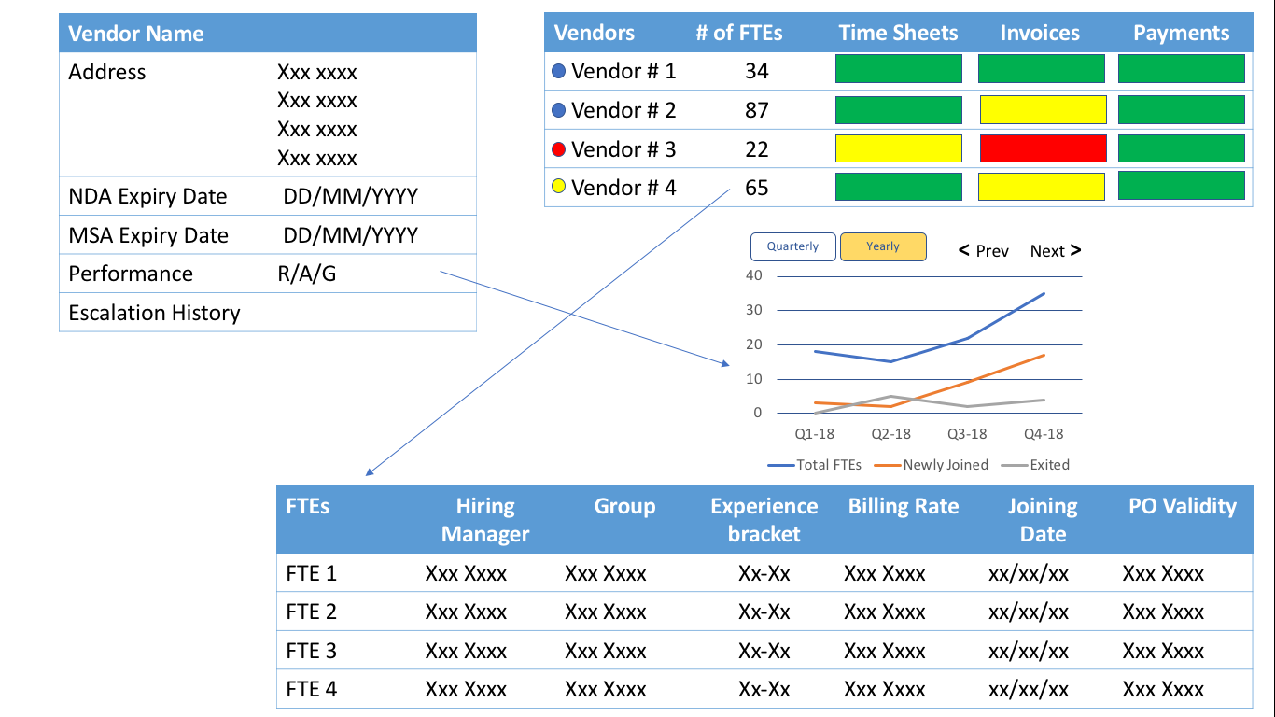

**Fig 1: DashBoard of VMO Page**

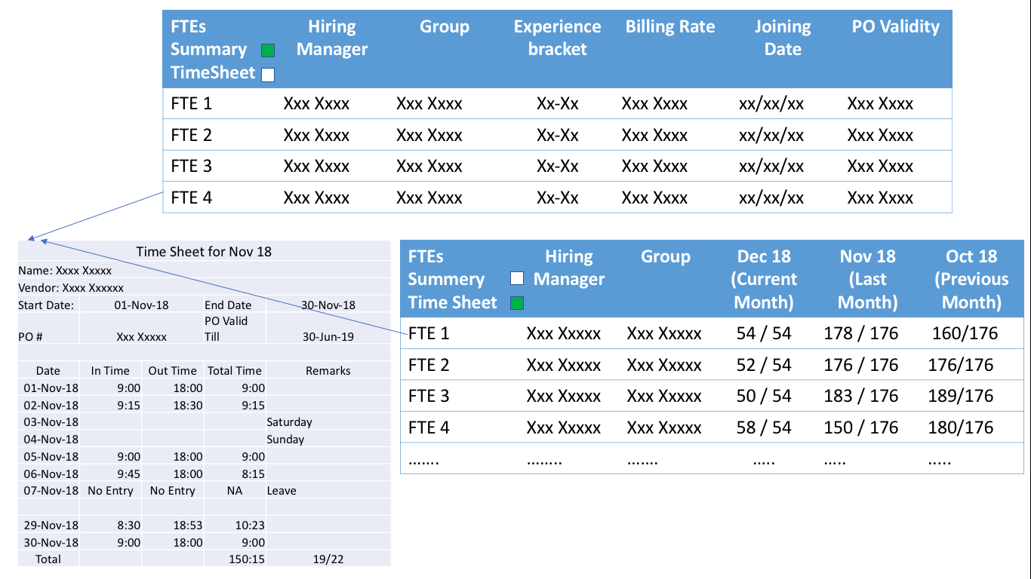

**Fig 2: Details of the FTEs and their timesheet**

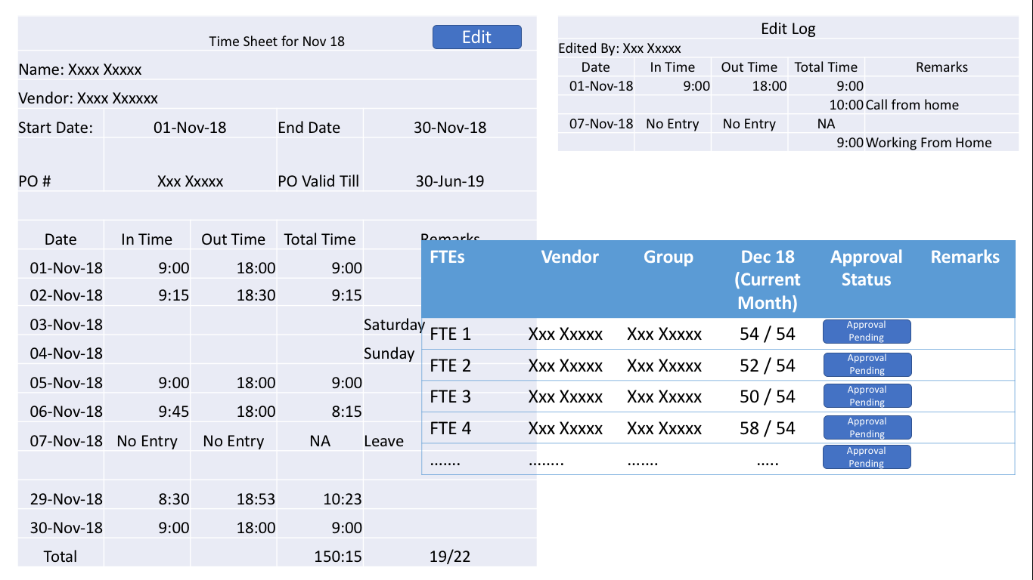

**Fig 3: Details access to Hiring Manager**

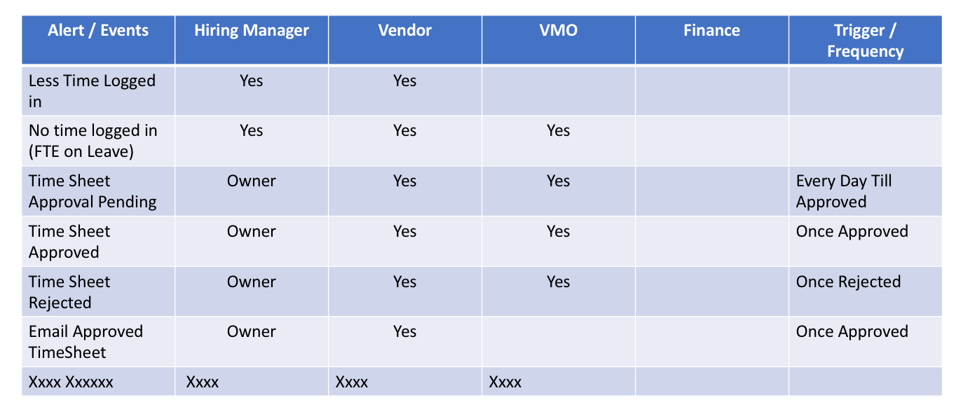

**Fig 4: Sample Access Permission Template**